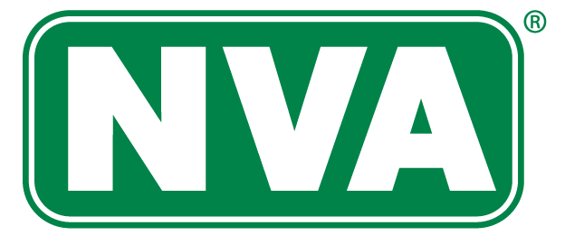
National Vision Administrators, L.L.C.

Enroll in your vision benefit by [insert date]
Instructions: Please select the paragraph that talks to your audience. Please delete the paragraph that does not apply as well as these instructions.
For existing members: Open Enrollment is here! Continue to care for your eyes with your low-cost vision care benefit administered by NVA. Visit the in-network eye doctor you want, to keep your eyes and your overall health in check. See why seeing an eye doctor that is part of the NVA network is a smart choice.

For new members: Vision care is more than choosing eyewear that reflects your personality; it’s about maintaining healthy, high functioning eyes through prevention and proper care. Enroll in a low-cost NVA vision care benefit to gain access to high-quality eye care as well as eyewear. See why enrolling in a vision benefit is a smart choice.

- Freedom to choose
Within the NVA vision care network, you have the freedom to choose who examines your eyes and where you buy your eyewear. Plus, you can pick your in-network NVA eye care professional based on the number of frames available to you at $0 out-of-pocket cost.
- Savings you want
The average cost of eyeglasses (lenses and frames) is more than $260¹. Tack on the cost of a retail comprehensive eye examination ($110) and you’re looking at nearly $400 out of your pocket. Having an NVA vision benefit can reduce this cost significantly. Did you know there are eyewear enhancements that you may be overpaying for or don’t need? Through the NVA Smart Buyer®, we help you figure out what you want and need in your eyewear, before you go to the store or eye doctor’s office.

- Stay on top of your health
Comprehensive eye exams do much more than just test your sight. They can detect the signs of a variety of health issues such as diabetes, hypertension, multiple sclerosis, and more. Early warnings can be vital for staying healthy and getting appropriate treatment. An NVA vision benefit makes eye exams affordable and accessible.

Enroll by [insert date]
Visit [client URL] or call [client phone number)
Contact NVA at www.e-nva.com or 1-800-672-7723
Resource: ¹National Association of Vision Care Plans.
In the state of California, NVA Vision Insurance Services & Administrators, L.L.C. (NVA®) is the legal name of the corporation through which NVA does business.
In the state of New York, NVA Vision Services & Administrators Agency is the legal name of the corporation through which NVA does business.
In the state of Texas, E-NVA, L.L.C. is the legal name of the corporation through which NVA does business.

© 2019. All Rights Reserved. The NVA logo and NVA Smart Buyer® are registered marks of National Vision Administrators, L.L.C.
V10112019

